**Analysing Global Dining Trends with Zomato Data**

**PROBLEM STATEMENT**

The challenge is to analyse the dataset to identify trends, preferences, and areas of improvement that can enhance the overall user experience on the platform. Specifically, the goal is to understand how different factors such as cuisine, location, price range, and ratings influence user choices and satisfaction.

**INSIGHTS**

1. **Distribution of Restaurant Ratings**

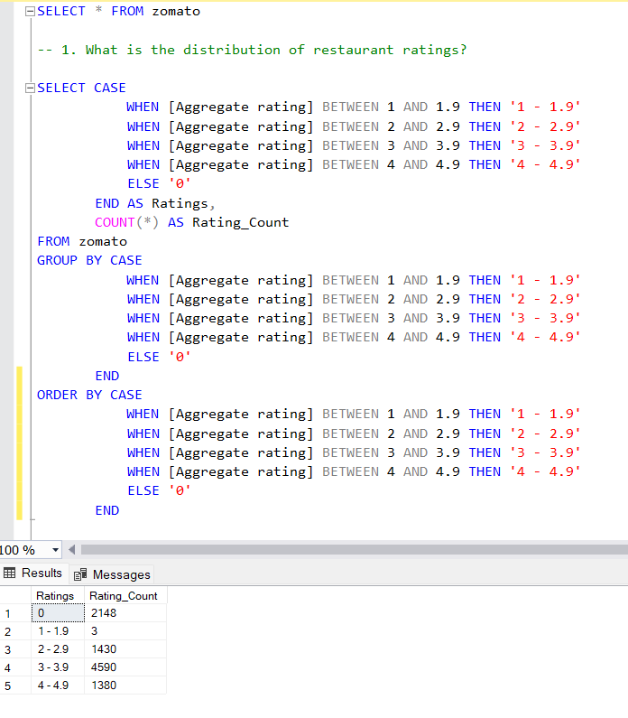

1. **Restaurant offering online delivery**

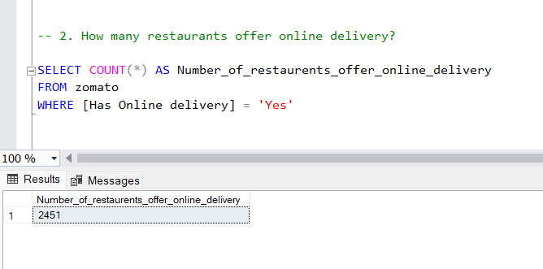

1. **Average Cost for two people**

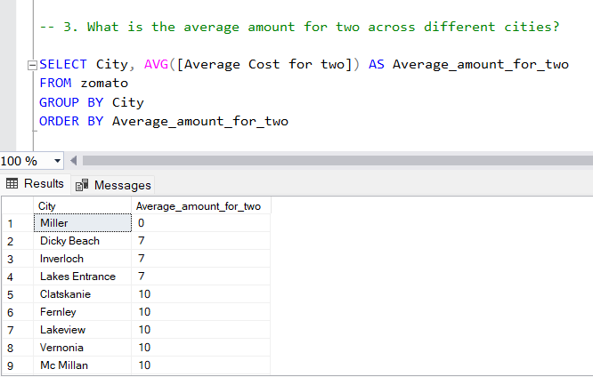

1. **Top Cuisines**

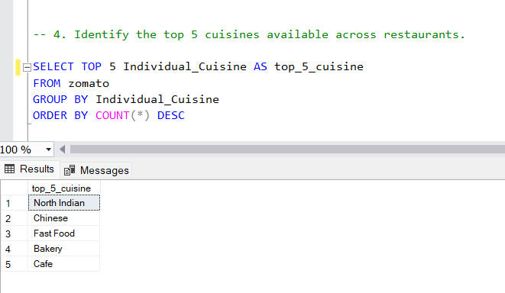

1. **Restaurants offering Table Booking**

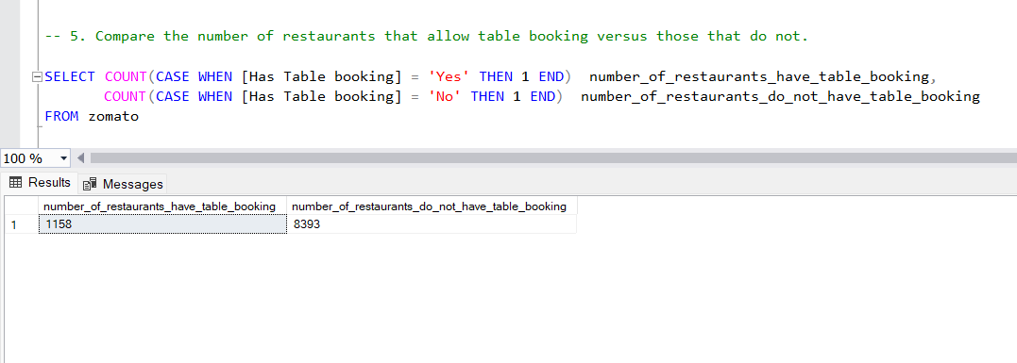

1. **Most Common Restaurant Names**

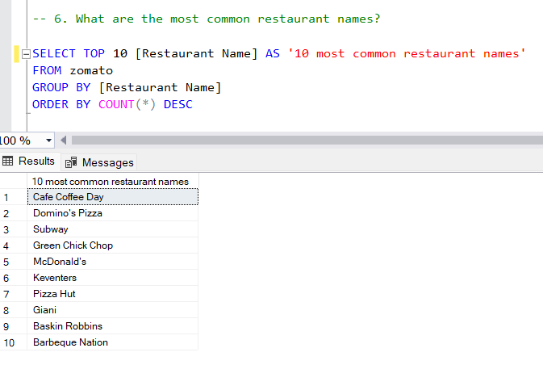

1. **Number of Unique Cities**

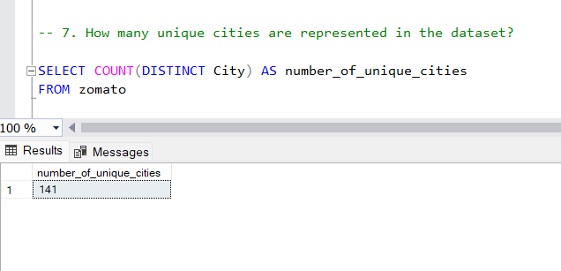

1. **Top 5 Restaurants**

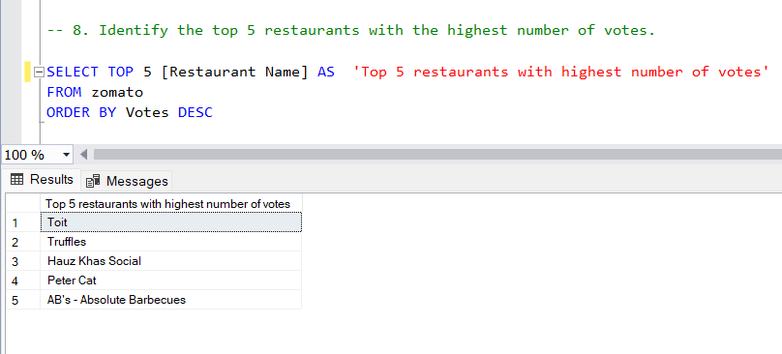

1. **Ratings Vary b/w restaurants that offer online delivery and those that do not**

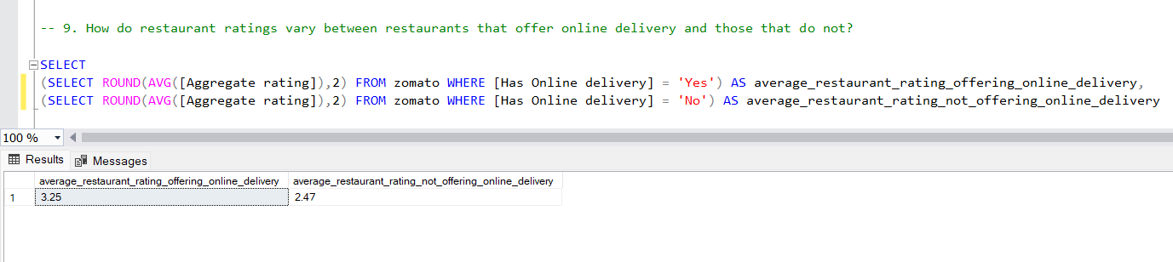

1. **Ratings Vary b/w restaurants that offer table booking and those that do not**

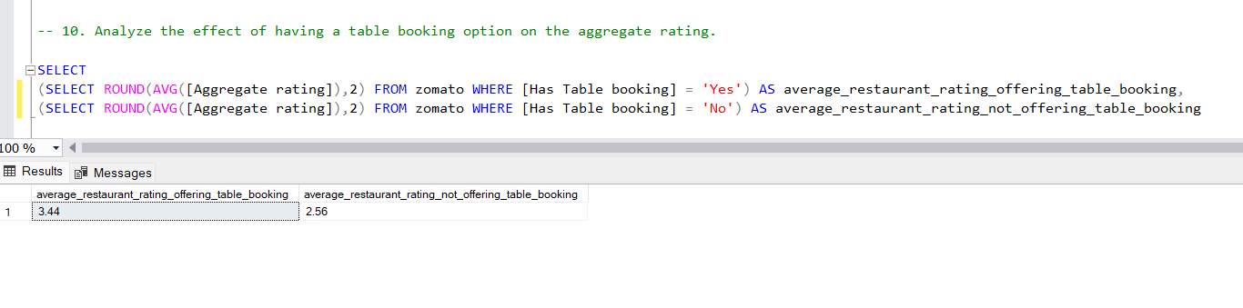

1. **Top Cities with Highest Average Rating**

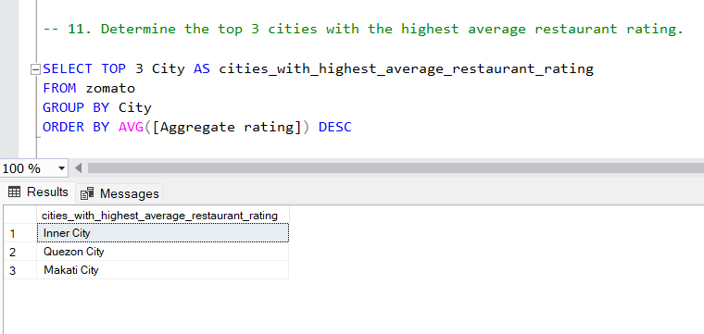

1. **Distribution of Restaurants across different Price Ranges**

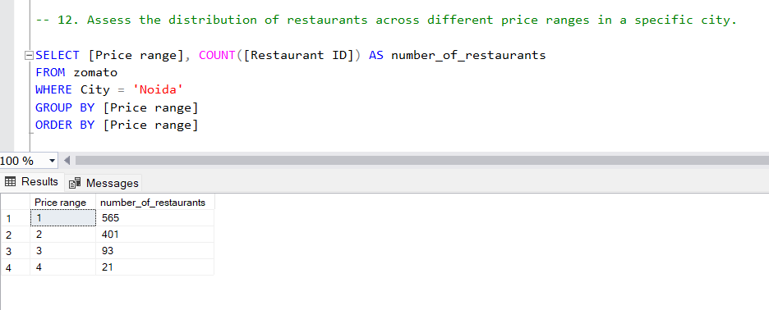

1. **Restaurant Ratings over different Price Ranges**

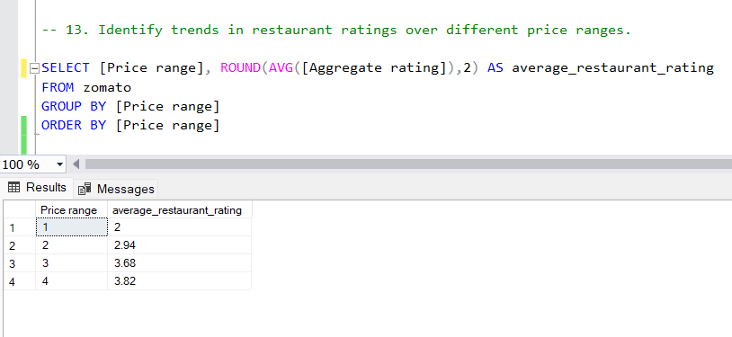

1. **Relationship between Price Range and Rating Color**

